**0014763433**

**001434737**

**Vedant Pednekar**

**Adithya Prasad**

**NORTHEASTERN UNIVERSITY**

*Design Documentation Proposal of*

**“**

**DATAWAREHOUSING & BUSINESS INTELLIGENCE**

*By*

*Team 2 - Data* *Wizards*

**Darshan Durve**

**001898887**

**Manya Raman**

**001497103**

*Under the guidance of*

**Professor**

**Vincent Lattuada**



**Document Revision History:**

|  |  |  |  |
| --- | --- | --- | --- |
| **Date** | **Who** | **What** | **Version** |
| 3/15/2020 | All Members | Initial proposal draft of the project submitted | **0.0** |
| 3/22/2020 | All Members | Final project proposal draft submitted | **1.0** |
| 3/23/2020 | All Members | Received feedback on proposal and went through it |  |
| 3/25/2020 | Every member created one table | Created dim provider and dim geography. Loaded the data into staging using SSIS. |  |
| 3/27/2020 | Manya and Darshan | Created the final ER diagram try to identify and identified lookups that can be used. |  |
| 3/30/2020 | Darshan and Adithya | Data Profiling using SSIS |  |
| 3/30/2020 | Manya and Adithya | EDA |  |
| 4/2/2020 | Darshan and Vedant | Created lookups and reference tables using online datasets |  |
| 4/3/2020 – 4/4/2020 | Manya, Darshan and Adithya | Started working on SSIS package to implement SCD and loaded using lookups for multiple years data. |  |
| 4/5/2020 | Adithya and Manya | Continued working on SCD implementation |  |
| 4/6/2020-4/7/2020 | All Members | Worked on the documentation by creating all transformation that need to be implemented in excel sheet to be submitted. |  |
| 4/8/2020 | All Members | Worked on the documentation to be submitted today. | **2.0** |
| 4/10/2020 | All members | Added date dimension as recommended and made changes in the design document as recommended by the professor. |  |
| 4/11/2020- 4/12/2020 | Adithya and Manya | Loaded all the datasets into staging table. |  |
| 4/13/2020-4/15/2020 | Manya and Darshan | Did transformations and loaded the data into fact tables. |  |
| 4/16/2020 | Darshan and Manya  And Adithya | Decided to remove opioid table and add the inpatient table. Did all the process of staging and moving to fact for this table. |  |
| 4/17/2020 | Adithya and Darshan | Give foreign key references and renaming tables and doing all the cleanups in SQL Server and everything. |  |
| 4/18/2020-4/19/2020 | Darshan and Manya | Made OLAP cubes and hierarchies in SSAS. |  |
| 4/19/2020-4/21/2020 | Darshan and Manya | Loaded data into tableau for visualization and created various dashboards. |  |
| 4/22/2020 | Adithya and Vedant | Added and made required changes to the design document |  |
| 4/22/2020-4/23/2020 | All Members | Made power point presentation and cleaned up everything for final submission | **3.0** |
| 4/22/2020-4/24/2020 | All Members | Gathered all the files to be submitted today and zipped and went over presentation |  |

**Objective:**

The main purpose of this project is to create a dynamic data warehouse consisting all the information on health care provider which will enable the users to identify the most optimal medical center for their healthcare needs. We hope to create comprehensive reports which provide details of the number of beneficiaries in each medical center and condition for which they are receiving treatments from the health care center. We also aim to provide users with costs associated with different medical services and drug services provided by each medical center which will allow users to understand treatment costs in each medical center. The final deliverable of this project is to create a dynamic data warehouse using ETL processes in order to create business intelligence dashboards about medical costs for various procedures and Medicare center performance across various states by doing the following:

* To analyze the amount the provider pays and the connection between the calculation of costs for medical procedures in different medical centers based on beneficiary conditions.
* To analyze the relation between the age of beneficiaries and the number of beneficiaries with chronic conditions treated under a specific provider.
* To analyze state-wise suppliers and their average payment info depending on the Durable Medical Equipment, Prosthetics, Orthotics and Supplies provided.
* Comparing the cost of medical procedures in each center with respect to the average cost for each condition of the beneficiary.
* Comparing the cost of medical equipment in each medical center with respect to the national average.
* Other ad-hoc analysis reports based on requirements.

**Data Source Description:**

All the datasets we selected and are described below are for multiple years from **2015** **to 2017**.

A through research on the Federal Governments website for Medicare centers and Medicaid Services data provided the team with 4 data sets which align with the goals of the project, they are:

1. The Medicare Physician and Other Supplier National Provider Identifier (NPI) Aggregate Report - This subset of this file will be the one of the main fact table for the project. It contains 1.09million rows and 70 columns which includes data of all the healthcare providers of the nation, which can be drilled down to the city level. This also provides us with the exact amount each provider charged for their benefactors and the amount that was covered by Medicare and the actual amount payed by the patients which is extremely crucial for our analysis. It also contains the percentage of beneficiaries with every chronic disease which each provider has giving us the information about each provider in extreme detail.

<https://data.cms.gov/Medicare-Physician-Supplier/Medicare-Physician-and-Other-Supplier-National-Pro/n5qc-ua94>

1. Medicare Referring DMEPOS HCPCS State Aggregate table - DMEPOS is short for Durable Medical Equipment, Prosthetics, Orthotics and Supplies. This dataset provides a comprehensive description of the DEMPOS product and services provided to Medicare beneficiaries ordered by physicians and other healthcare professionals. It proves to be useful by providing us with the average supplier payment amount and the average allowed Medicare amount categorized by state and DEMPOS product or service. It also provides with the number of providers offering these services to the number of suppliers rendering these services. This data set contains 40k rows and 15 columns as shown below:

<https://data.cms.gov/Medicare-Durable-Medical-Equipment-DME-/Medicare-Referring-DMEPOS-HCPCS-State-Aggregate-ta/kpkt-855d>

1. State Summary of Inpatient Charge Data- The Inpatient PUF includes information on utilization, payment (total payment and Medicare payment), and hospital-specific charges for the more than 3,000 U.S. hospitals that receive Medicare Inpatient Prospective Payment System (IPPS) payments. Each row is described as a drug per state. It consists of 27.5k rows and 6 columns. The entire dataset can be found below:

<https://data.cms.gov/Medicare-Inpatient/State-Summary-of-Inpatient-Charge-Data-by-Medicare/q5hc-zvkx>

1. Medicare Provider Utilization and Payment Data - This dataset provides details on services and procedures provided to Medicare beneficiaries by physicians and other healthcare professionals. The Physician and Other Supplier PUF contains information on utilization, payment (allowed amount and Medicare payment), and submitted charges organized by National Provider Identifier (NPI), Healthcare Common Procedure Coding System (HCPCS) code, and place of service. This data set allows users to find out the average number of beneficiaries under each health care practitioner and the cost charged by each provide along with the amount covered by Medicare per HCPCS code. This data is extremely comprehensive consisting of 9.85 million rows and 25 columns. The entire data set can be seen below:

<https://data.cms.gov/Medicare-Physician-Supplier/Medicare-Provider-Utilization-and-Payment-Data-Phy/fs4p-t5eq>

**Source to Destination Mapping Flow:**

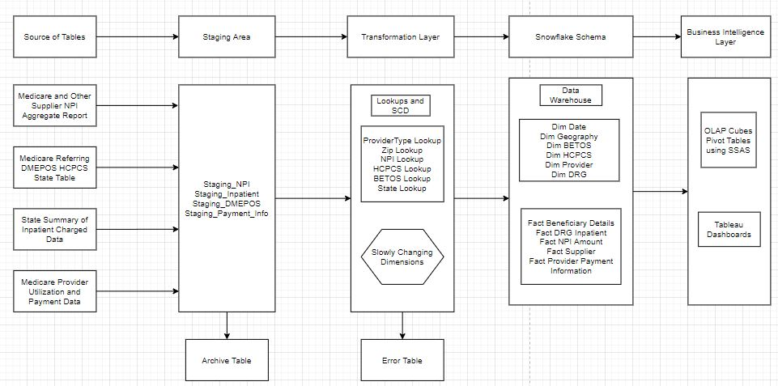

**ETL Process:**

Flow of the Data in the ELT process with potential tools:

1. Firstly, we created a for each loop container which has a Data Flow task to dump the sample dataset files from year 2015-2017 to the staging table. We added a Derived column component in between to create a ‘Year’ column for the indication of the year of the file being loaded. It took the FileName value of the dataset file containing the year.

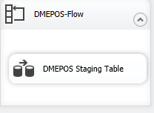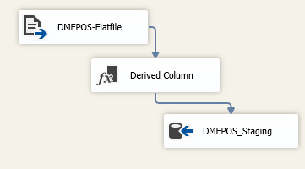

1. Secondly, we profiled the above files using tools like Visual Studio which give us the in-depth analysis of columns as well as the whole dataset in form of column length and uniqueness, Null value analysis, accuracy and completeness etc. This helped us in understanding the transformations needed to be done on the data during the loading process.

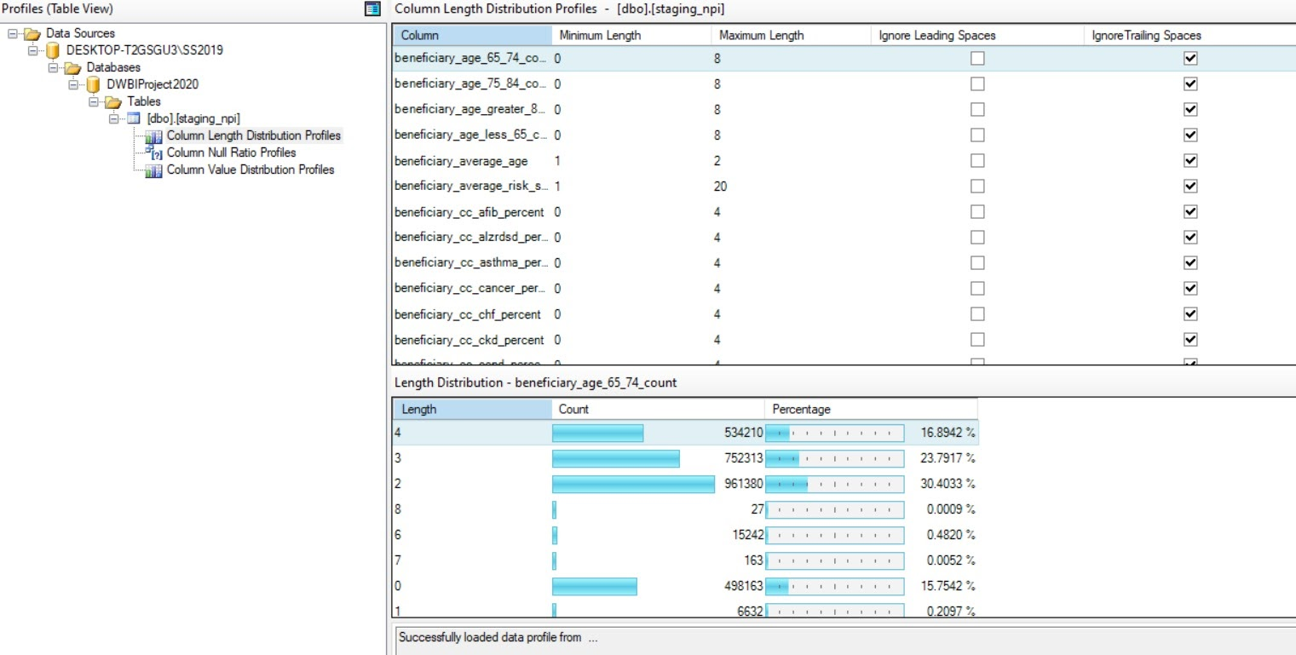

1. Going forward, the data from staging table is loaded into the Destination column while checking for changing fields via the Slowly Changing Dimension component. So that dimension like provide will not get added every year only if something changes then it will go into changing dimension output. For fact tables every year data gets loaded with year column as derived above. We also inserted the Lookup component in between to load only those records with fields which had reference in the Lookup tables. This way we get the accurate records in the Destination area

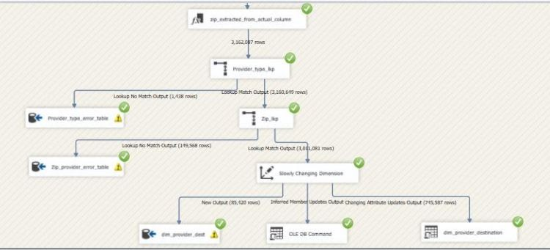

1. We retrieved the Lookup table datasets from the internet and created Lookup tables for provider type, state, HCPCS type, DRG type BETOS id and zip code. Each was given and incremental reference ID which was then inserted to the destination tables via the Lookup up component while moving data from staging to destination

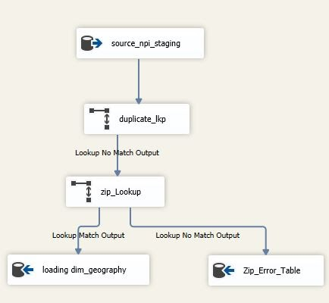

1. We also made some transformations to the data wherever necessary like converting the data format from varchar to its appropriate data type and also an extra column was added for HCPCS type where the codes were classified into two types.

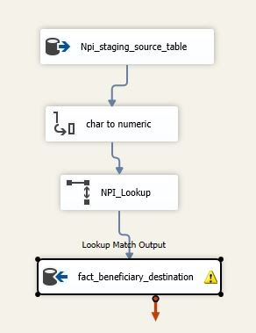

1. The unwanted records are then passed on to the Error tables for further analysis and inspection. We archived the data from the staging table so that initial unchanged load will be saved before the transformation to load it into our destination tables.
2. We leveraged the Snowflake schema for building the EDW destination table. This is done in SQL Server Management Studio itself by altering the tables and adding foreign key constraints for each table and making sure that all the tables were in 3rd normal form which was then fed into the business intelligence layer.\
3. We performed analytics on the schema by forming an OLAP cube. We were able to create hierarchies for provider geography, provider and HCPCS which enabled us to create measure groups on SSAS such as number of beneficiaries by state over the 3 year time period, the average Medicare payments made by beneficiaries in each state over the same time period or the number suppliers associated with each medical center.

1. We then made visualizations to view the results and created reporting dashboards using calculated columns in tableau as shown below.

**E-R Diagram: EDW Schema**



**Tableau Visualizations:**

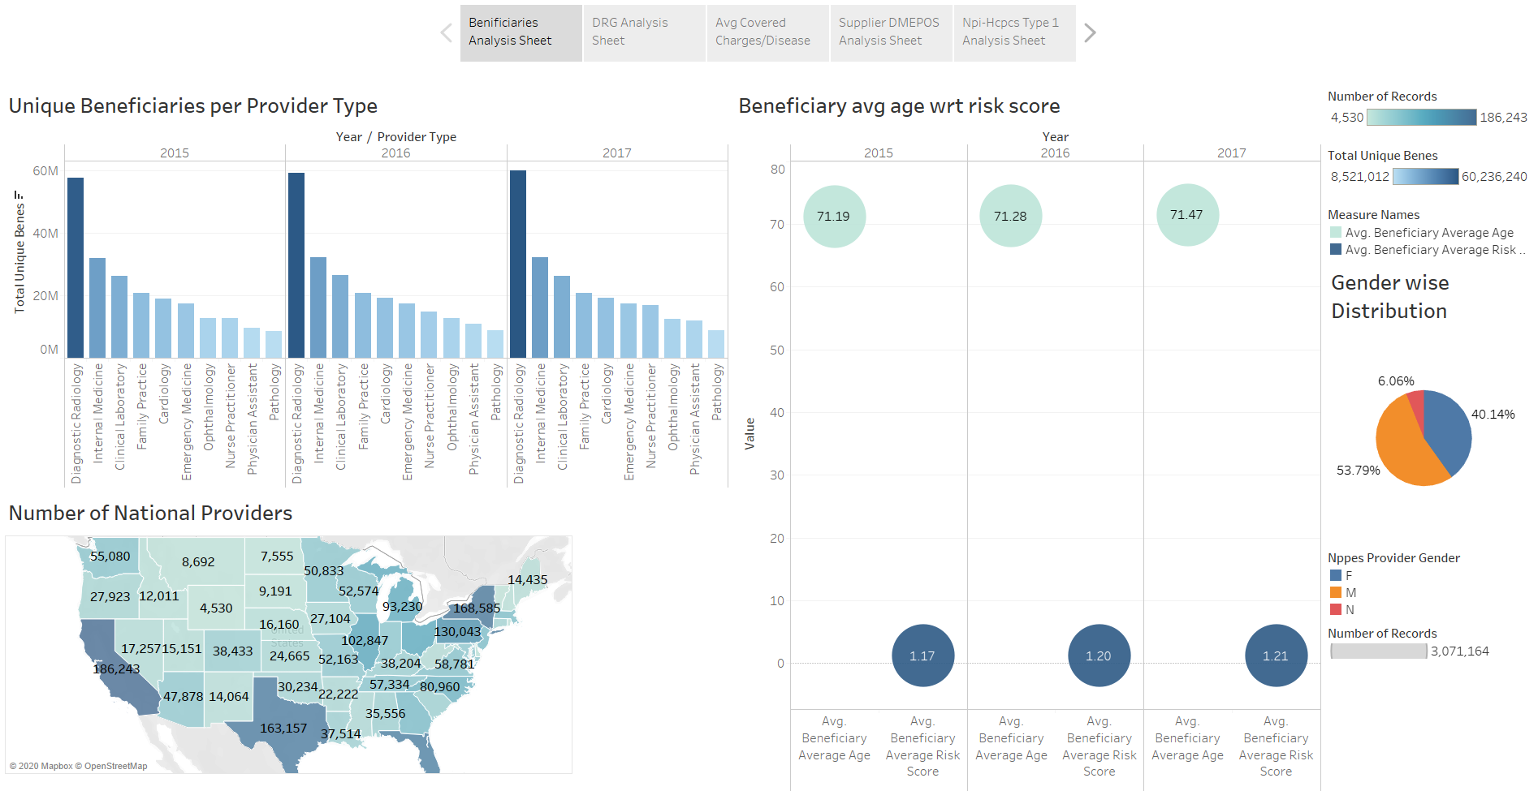

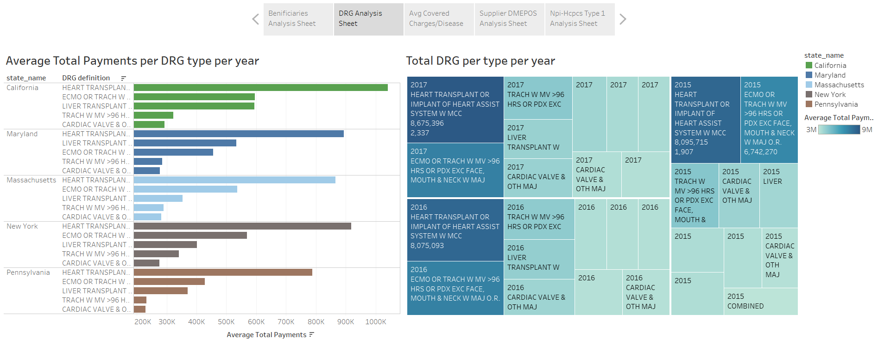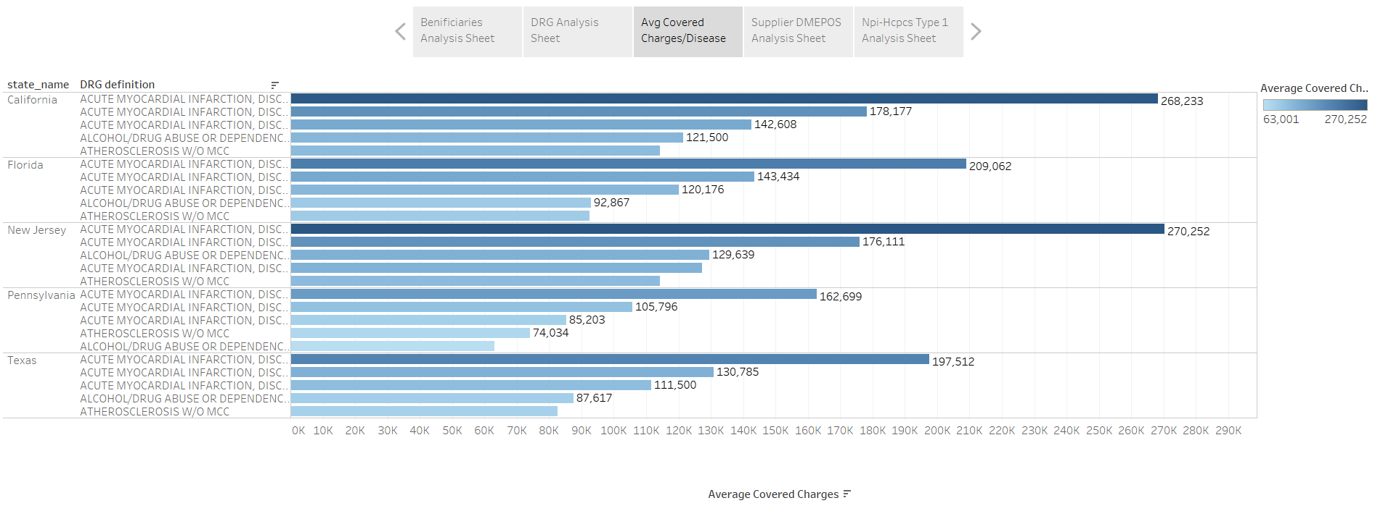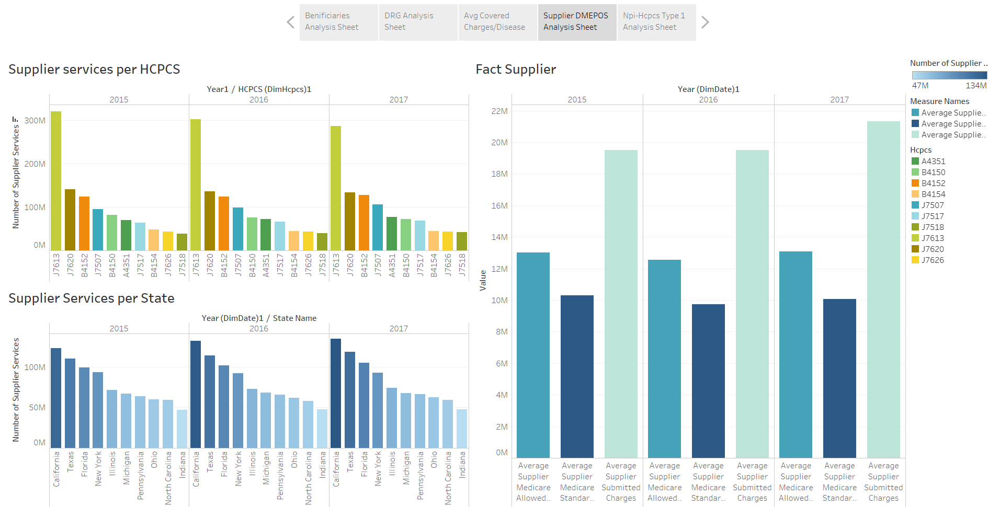  
  
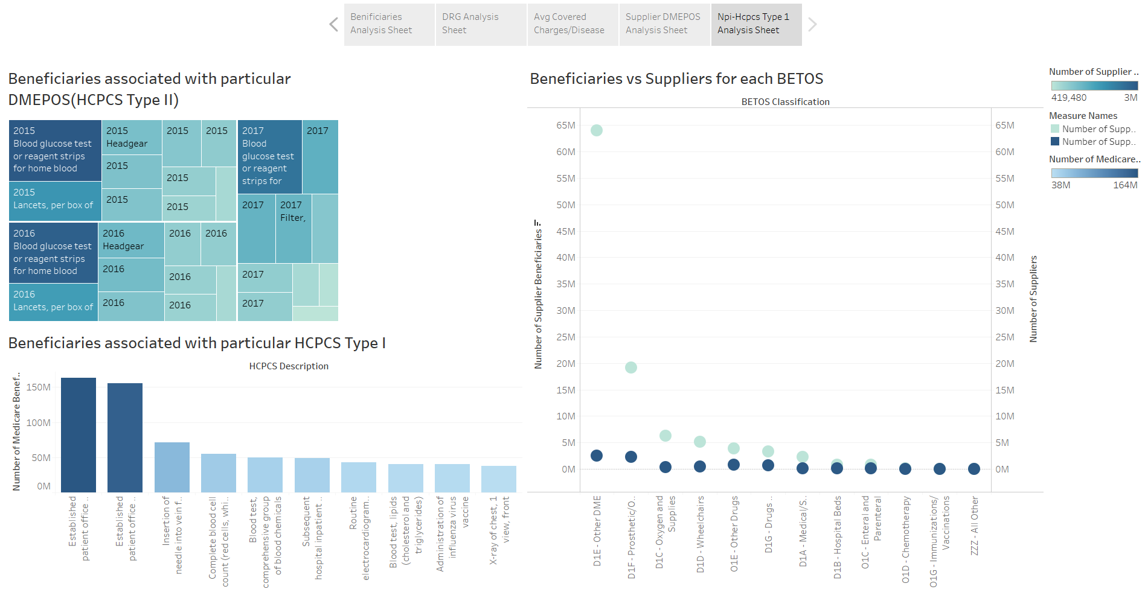

**Insights:**

The analysis of the different datasets yields some interesting insights which help us in creating visualizations, these insights are as follows:

* Diagnostic Radiology has the most consistent unique consumers over the years for all US states
* The Average Risk score increases as Average Beneficiary Age increases proportionally
* California #1 in terms of total payments for diseases paid by the Insurance Companies
* Health transplant /Implant has the highest paid amount for all the years ~ $8,675,396, while average coverage charges is the best for Acute Myocardial Infarction in all the states
* Maximum number of Supplier Services involve supply of medical drug Albuterol and the highest number of supplier’s service to California
* Average allowed amount & the standard amount allotted to suppliers remains constant while the Average charges submitted by supplier keeps on increasing YoY
* For the type 2 services - Blood glucose test is #1 supplied equipment by the suppliers prescribed by the maximum number of healthcare providers. It had the beneficiary count ~ 3,470,023 in 2015 which lowered down to 2,901,900 in 2017
* For the type 1 services - Outpatient visit (typically 15 mins) had the greatest number of beneficiaries all the years combined, followed by outpatient visit (25 mins) and Needle insertion for blood sample category

**Results:**

* The Medicare Data warehouse provided a granular insight on demographic & economic evaluation of Medicare companies, providers, equipment suppliers & beneficiaries
* Health care providers and the companies have invested the most in sectors of Diagnostic Radiology,

Internal Medicine and Clinical Laboratory with regards to insurance plans

* Considering the volume of healthcare providers in the California, Insurance companies in that state repay the most dollar amount
* Heart Transplant has the highest repayment statistics for all the years for all the top repaid states
* The best coverage is received by beneficiaries residing in New Jersey state
* Albuterol is presumably the best in-demand product in market since it has the most number of suppliers in US
* Suppliers & medical manufacturers supplying glucose test equipment are making the most money
* Consumers are likely to invest in Healthcare plans involving Outpatient visits and blood test labs
* Overall, this warehouse digs deep and provides strategies as to how to grow the insurance business as well provide the consumers with dynamic view about the best plans to invest in & most optimal medical centers to visit for each chronic condition